Get R/RStudio – Step-by-Step Instructions

Modified from Dr. Allison Horst (@allison_horst).

# Why am I reading this?

We will use R and RStudio for everything in our coding course. R is basically the brains of the operation, and RStudio gives you a much more user-friendly interface to work with.

The step-by-step instructions in this document are to help you get R/RStudio on your own computer, along with several tools we’ll be using during our class. **DO THIS BEFORE August 14th. If you have problems, bring your issues to class on Wenesday, August 14th.**

*Note: If you have older versions of R/RStudio installed, we recommend updating. To get the updated version of R, just follow the instructions below. To update RStudio, you can follow the instructions below OR go to the ‘Help’ tab in RStudio, click on “Check for Updates,” then choose “Quit and Download” if you’re running an older version, then follow instructions below to download the newest version.

# Step 1: Get R (it’s free!)

1. Go here: <https://cran.rstudio.com/>
2. Choose the correct “Download R for…” option from the top (probably Mac or Windows), then:
   1. **For Mac users**, select the appropriate version for your operating system (e.g. the latest release is version 4.3.1, will look something like R-4.3.1.pkg), then choose to Save or Open
   2. **For Windows PC users**, choose “Install R for the first time” (next to the *base* subdirectory) and then “Download R 4.3.1 for Windows”
   3. Once downloaded, save, open once downloaded, agree to license, and install like you would any other software. If it installs, you should be able to find the R icon in your applications:



# Step 2: get RStudio Desktop (it’s also free!)

RStudio is a user-friendly interface for working with R. That means you **must have R already installed** for RStudio to work. Make sure you’ve successfully installed R in Step 1, then…

1. Go to<https://www.rstudio.com/products/rstudio/download/> to download **RStudio Desktop** (Open Source License). You’ll know you’re clicking the right one because it says “FREE” right above the download button.
2. Click download, which takes you just down the page to where you can select the correct version under **Installers for Supported Platforms** (almost everyone will choose one of the first two options, RStudio for Windows or Mac OS X).
3. Click on the correct installer version, save, open once downloaded, agree to license and install like you would any other software.

# Step 3: Open RStudio and make sure everything is working!

1. Once you have R then RStudio installed, you can find and click on the RStudio icon to open. When you open RStudio, it automatically also runs R. So even though you’ll be using both, you only need to actively open RStudio. The RStudio icon looks like this:



1. When you open RStudio, you should get a workspace that looks something like the screen shown below. Does that (or something similar - your R version will be newer) show up? If yes, you have R and RStudio installed correctly, and you can move on to Step 4.

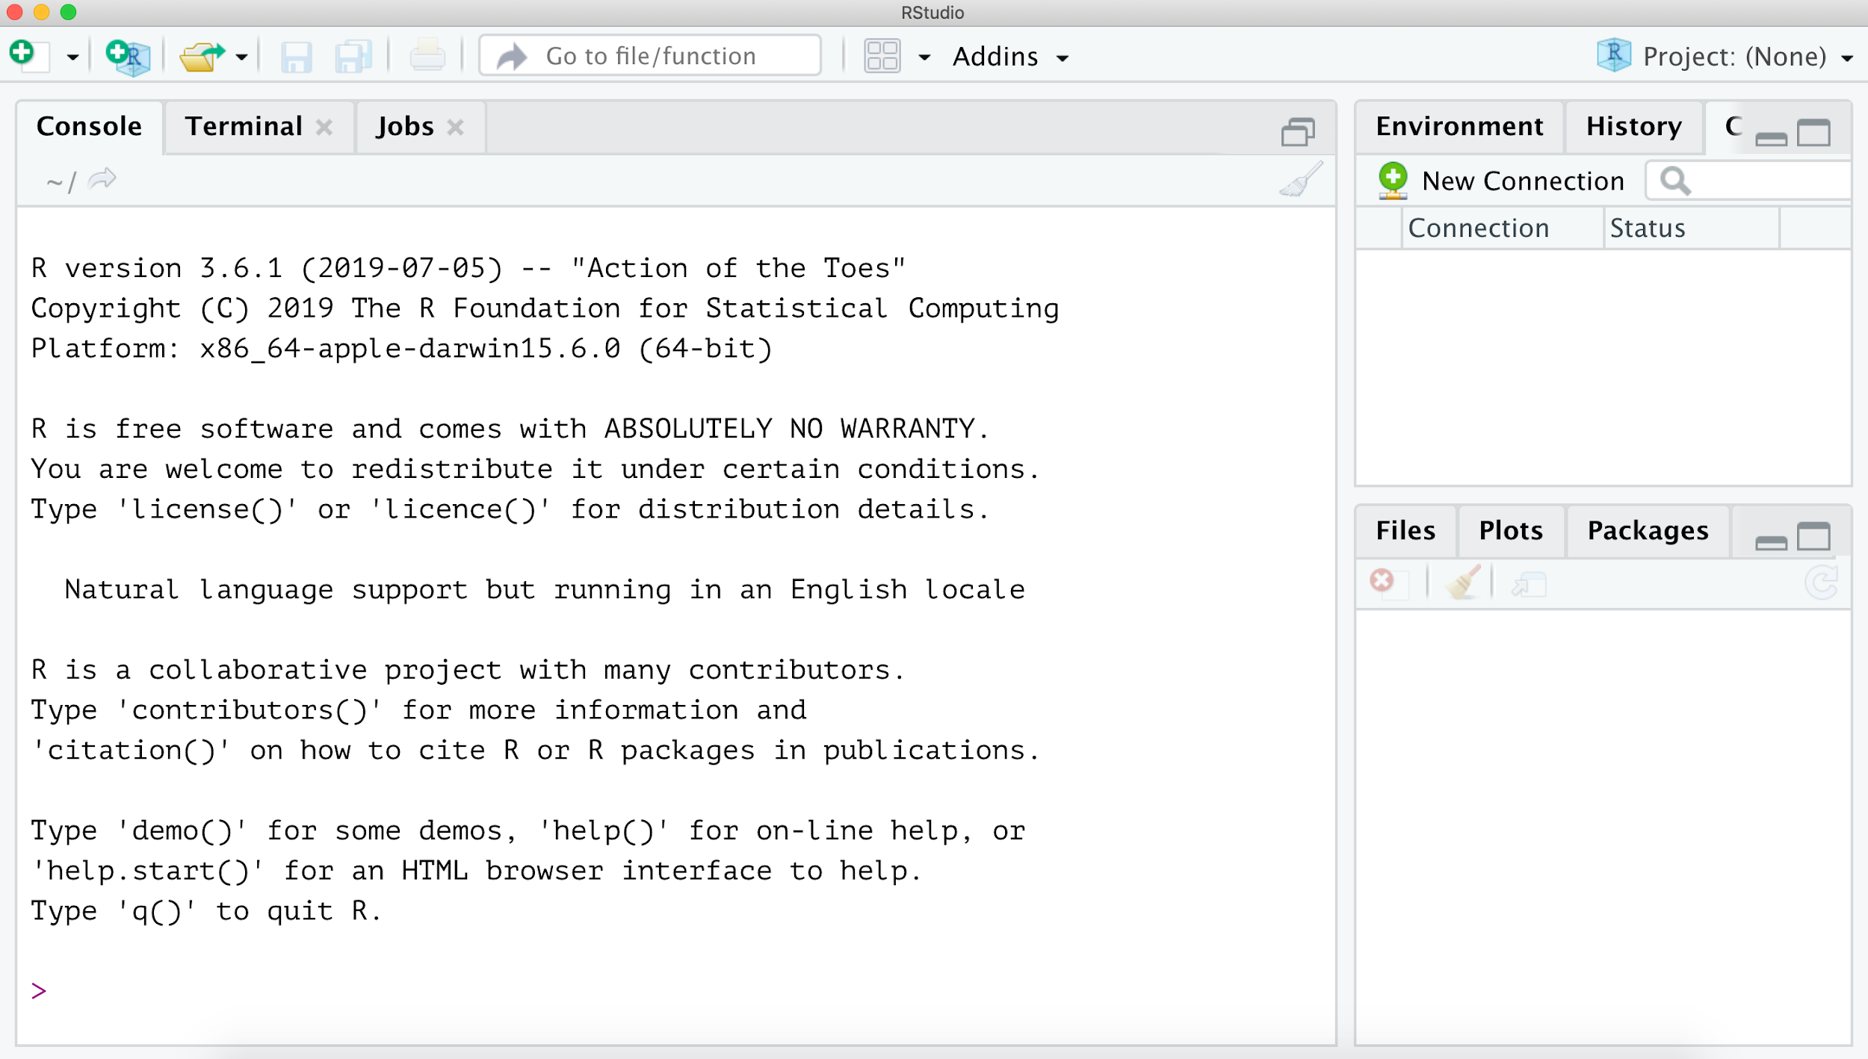

# Step 4: Install tidyverse package

When you install R, it comes with a bunch of built-in tools that are automatically installed with it. There also exist additional tools and packages that will make your life much easier. For much of our work, we’ll use packages that exist in the aggregate *tidyverse* package. The tidyverse contains a collection of very useful packages that play nicely together for data exploration, manipulation, wrangling and visualization (among other things). Here, you’ll install the *tidyverse* package.

1. Open RStudio
2. In the CONSOLE WINDOW of RStudio, you should see an active cursor waiting patiently for you to type something:

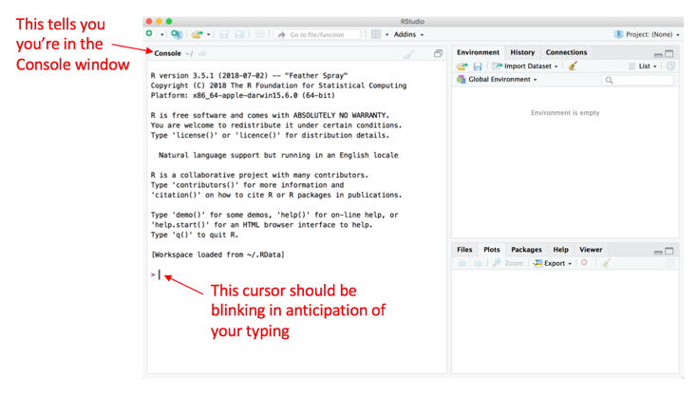

1. To install the tidyverse, **type** the following (exactly) where that cursor is waiting, then press ‘Enter’. Note: if you copy and paste, you may need to replace the quotation marks (this can lead to an error - we recommend just typing in the line below to avoid).

install.packages(“tidyverse”)

1. After you press ‘Enter,’ you should see a whole bunch of text starting to appear in the Console Window. That’s good – it’s just a record of what’s being downloaded/installed. This process can go on for a few minutes (the tidyverse has a lot of different components).

You will know it’s done when you get something like this (yours will differ slightly), with no red error messages, and the active cursor shows up again waiting for your next command:

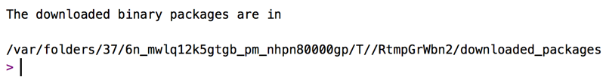

1. Once it’s installed, you can ensure that everything worked by *loading* the tidyverse package (that just means that it’s bringing the package into R’s active brain, instead of just existing in its dormant storage). To load the tidyverse package you’ve just installed, type the following into the Console in RStudio where the active cursor is waiting, then press ‘Enter’:

library(tidyverse)

When you press enter, some information will come up below the command (this might also take a minute or two to load). Mine looks like this (your versions may differ):

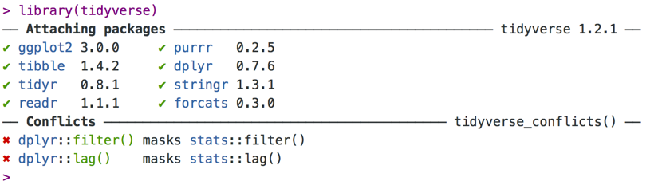

If you got something similar with no error messages (different from the ‘Conflicts’ section – that’s fine, as we’ll also learn later) then you’ve successfully installed R, RStudio, and the tidyverse package.

**Congratulations!** Now you can close RStudio (you don’t need to “Save the Workspace” or anything else when prompted).